Michael Hart

Bioinformatics

Homework 3

My research question is why *C. auris* displays such strong adhesive properties compared to closely related fungi. The gene I chose (CJI97_000055) contains a large segment belonging to the GPI (glycophosphatidylinositol)-anchored superfamily, which has been implicated as a unique contributor to *C. auris* stickiness (Muñoz et al. 2018). The GPI anchor is a modification added to the C-terminus of proteins after translation that allows the modified protein to be anchored in the cell membrane’s outer leaflet, in some cases contributing to cell-cell contact and adhesion (Paulick and Bertozzi, 2018). Phylogenetic analysis may provide hints as to when and in what species either CJI97_000055 or the GPI-anchored superfamily expanded compared to closely related *Candida* species.

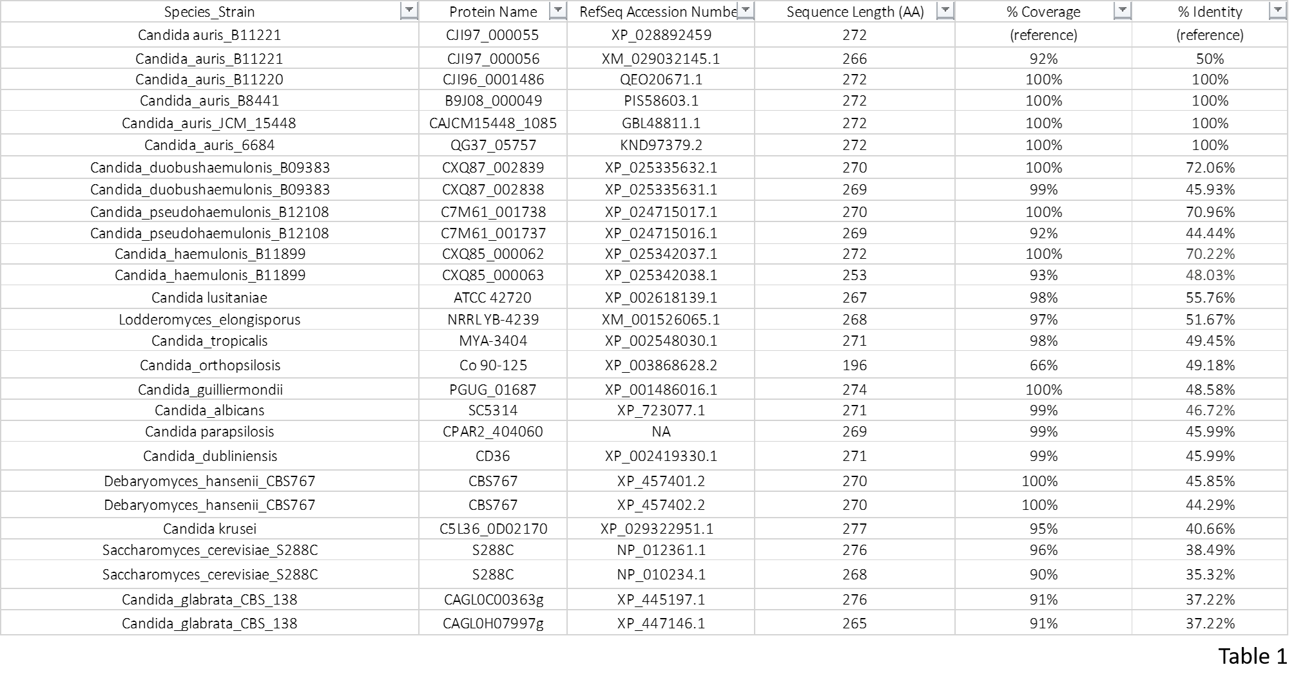

Table 1

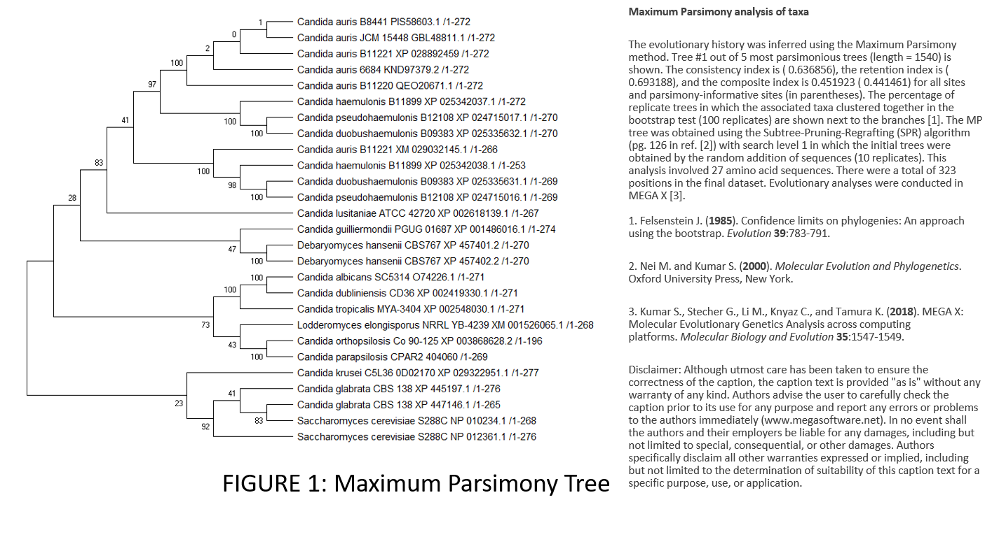

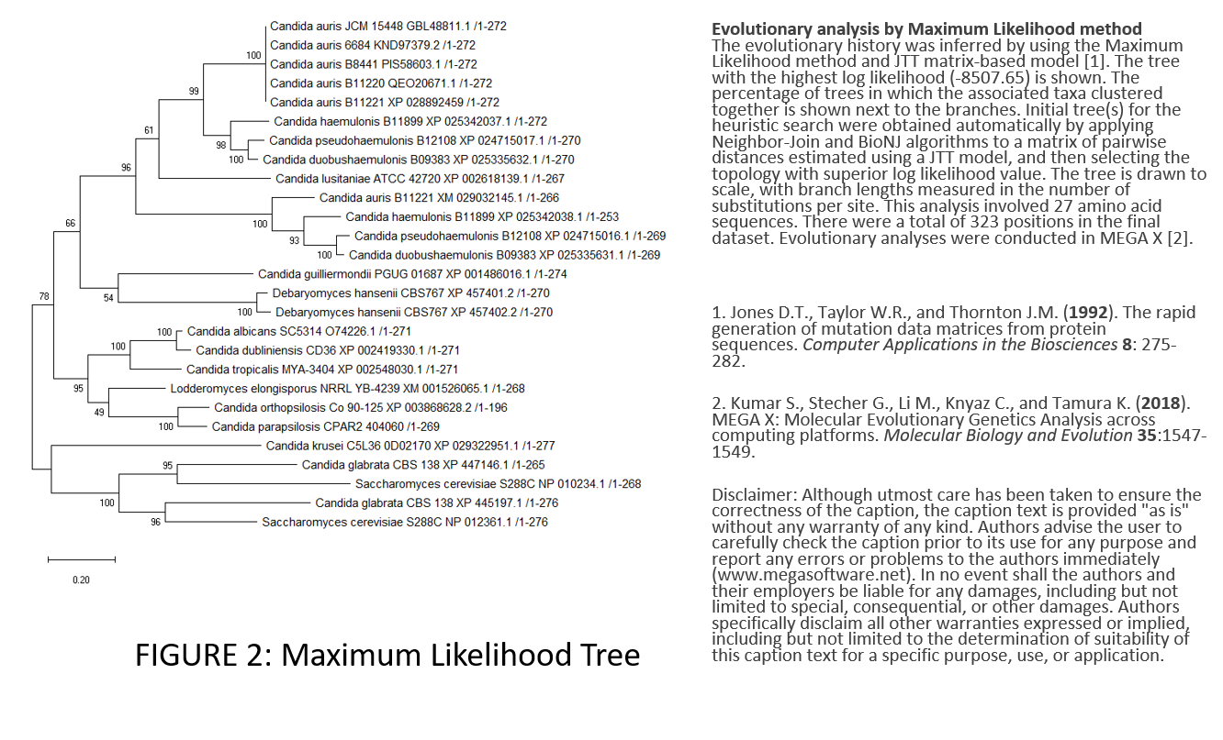 Both my maximum parsimony tree and maximum likelihood trees match fairly well with Fig. 3 of Muñoz et al. 2018 (which is a maximum likelihood tree) when rooted on the branch containing *Candida krusei, Candida glabrata,* and *Saccharomyces cerevisiae*. My trees both suggest that the CJI97_000055 protein underwent duplication events followed by speciation events in strains of the species *C. auris*, *C. duobushaemulonis*, *C. haemulonis*, *S. cerevisiae*, and *C. glabrata*. There are at least six homologs in *C. auris* in both trees (the highest for any species on the tree), indicating that the CJI97_000055 gene expanded most in *C. auris*. The most noticeable difference between the trees is that the maximum likelihood tree has *S. cerevisiae* and *C. glabrata* display a duplication followed by two speciations, whereas the maximum parsimony tree shows a speciation followed by one duplication. Assuming I have located most of the homologs, my trees also indicate that most of the copies of the CJI97_000055 gene are in strains that are pathogenic and multi-drug resistant, as indicated by Fig. 3 of Muñoz et al. 2018. The only exceptions to that pattern are *S. cerevisiae* and *D. hansenii*.